**AMALIY MASHG‘ULOT UCHUN O‘QUV MATERIALLARI**

**2-Mavzu:** PyQt5 paketi va QtDesigner dasturi yordamida GUI dasturlarini yaratish.

**5-mashg‘ulot.** PyQt da rasmlar va menyular.

O‘quv savollari:

1. PyQt paketi yordamida rasm joylashtirish usullari.
2. Menu yaratish. Menu vidgetining xususiyatlari.

**1. PyQt paketi yordamida rasm joylashtirish usullari**

**QPixMap vidjeti**

**QPixMap –** butasvirlarni ekranga chiqarish uchun ishlatiladigan vidjetlardan biri. Quyidagi misolda tasvirni ekranda ko‘rsatish uchun **QPixMap** metodidan foydalanilgan.

import sys

from PyQt5.QtWidgets import *

from PyQt5.QtGui import QPixmap

class Example(QWidget):

def __init__(self):

super().__init__()

self.initUI()

def initUI(self):

h_box = QHBoxLayout(self)

pixmap = QPixmap("blue_black.png")

lbl = QLabel(self)

lbl.setPixmap(pixmap)

h_box.addWidget(lbl)

self.setLayout(h_box)

self.move(300, 200)

self.setWindowTitle('Blue and Black')

self.show()

if __name__ == '__main__':

app = QApplication(sys.argv)

ex = Example()

sys.exit(app.exec_())

Ushbu dasturda blue_black.png nomli rasmni oynada ko‘rsatish uchun quyidagi amallarni bajarildi:

1. pixmap = **QPixmap**("blue_black.png") - **QPixMap** sinfi ob’yekti yaratildi.
2. lbl = **QLabel**(self)

lbl.**setPixmap**(pixmap) - rasmni QLabel vidjetidan foydalanib ekranga joylashtirildi.

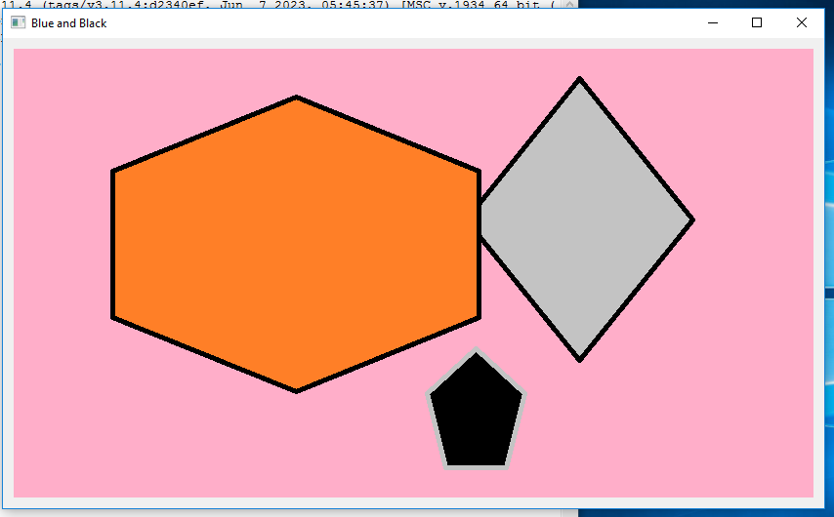

*71-rasm. QPixMap vidjetiga rasm joylashtirilgandagi ko‘rinishi*

**2. Menu yaratish. Menu vidgetining xususiyatlari.**

PyQt5 ga bag‘ishlangan bobning ushbu qismida menyu va asboblar paneli (asboblar paneli) vidgetlaridan foydalanishni ko‘rib chiqiladi.

Menyu - bu menyu satrida joylashgan buyruqlar guruhi. Asboblar panelida ilovadagi ba’zi umumiy buyruqlar uchun tugmalar mavjud.

**Menyu paneli**

Menyu paneli GUI ilovasining umumiy qismidir. Bu turli xil menyularda joylashgan buyruqlar guruhi.

import sys

from PyQt5.QtWidgets import *

from PyQt5.QtGui import QIcon

class Example(QMainWindow):

def __init__(self):

super().__init__()

self.initUI()

def initUI(self):

exitAction = QAction(QIcon(‘exit.png‘), ‘&Exit’, self)

exitAction.setShortcut(‘Ctrl+Q’)

exitAction.setStatusTip(‘Exit application’)

exitAction.triggered.connect(qApp.quit)

self.statusBar()

menubar = self.menuBar()

fileMenu = menubar.addMenu(‘&File’)

fileMenu.addAction(exitAction)

self.setGeometry(300, 300, 300, 200)

self.setWindowTitle(‘Menubar’)

self.show()

if __name__ == ‘__main__’:

app = QApplication(sys.argv)

ex = Example()

sys.exit(app.exec_())

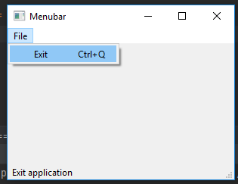

Menubar widgetining ilovada ko‘rinishi.

Yuqoridagi misolda bitta  menubar vidgeti yordamida menyu panelini yaratildi. Ushbu menyu tarkibida dasturni to‘xtatadigan bitta buyruq kiritilgan.  Ushbu buyruqni menular panelidan sichqoncha bilan tanlash yoki klaviaturadan Ctrl + q tugmalari yordamida ishga tushirish ham mumkin.

**Datur tahlili:**

exitAction = QAction(QIcon(‘exit.png‘), ‘&Exit’, self)

exitAction.setShortcut(‘Ctrl+Q’)

exitAction.setStatusTip(‘Exit application’)

* Ushbu uchta qatorda tegishli belgi bilan hodisa yaratilgan. Bundan tashqari, ushbu hodisa uchun tugmalar birikmasi aniqlanadi. Uchinchi qator kursorni menyu bandi ustiga olib borilganda satr yonida maslahatchiga o‘xshagan yozuv yaratadi.

exitAction.triggered.connect(qApp.quit)

* Ushbu maxsus harakatni tanlaganimizda, signal ishga tushadi. Signal **QApplication** vidjetining **quit()** metodini ishga tushiradi va ilovani yakunlaydi.

menubar = self.menuBar()

fileMenu = menubar.addMenu(‘&File’)

fileMenu.addAction(exitAction)

* Bu yerga **menyuBar()** vidgeti yordamida bitta menular satri yaratilyapdi.  fileMenu o‘zgaruvchisiga menular satrifa File nomli menu qo‘shish buyrug‘i yuklanmoqda. Va uchinchi satrda Fayl menyusining tarkibida dasturdan chiqish amalini qo‘shilmoqda.

**Asboblar paneli (toolbar)**

Menyular ilovada foydalanishimiz mumkin bo‘lgan barcha buyruqlarni guruhlaydi.

Asboblar paneli eng ko‘p ishlatiladigan buyruqlarga tezkor kirishni ta’minlaydi.

import sys

from PyQt5.QtWidgets import *

from PyQt5.QtGui import QIcon

class Example(QMainWindow):

def __init__(self):

super().__init__()

self.initUI()

def initUI(self):

exitAction = QAction(QIcon(‘exit24.png‘), ‘Exit’, self)

exitAction.setShortcut(‘Ctrl+Q’)

exitAction.triggered.connect(qApp.quit)

self.toolbar = self.addToolBar(‘Exit’)

self.toolbar.addAction(exitAction)

self.setGeometry(300, 300, 300, 200)

self.setWindowTitle(‘Toolbar’)

self.show()

if __name__ == ‘__main__’:

app = QApplication(sys.argv)

ex = Example()

sys.exit(app.exec_())

Bu yerda deyarli hamma narsa status paneliga o‘xshaydi.

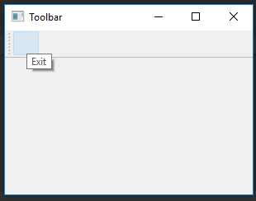

Asboblar panelining ilovada ko‘rinishi.

**Hammasini birlashtirish**

Ushbu bo‘limning oxirgi misolida menyu satri, asboblar paneli va holat panelini yaratildi. Shuningdek, markaziy vidjetni ham ular bilan birlashtirilgan.

import sys

from PyQt5.QtWidgets import *

from PyQt5.QtGui import QIcon

class Example(QMainWindow):

def __init__(self):

super().__init__()

self.initUI()

def initUI(self):

textEdit = QTextEdit()

self.setCentralWidget(textEdit)

exitAction = QAction(QIcon(‘exit24.png‘), ‘Exit’, self)

exitAction.setShortcut(‘Ctrl+Q’)

exitAction.setStatusTip(‘Exit application’)

exitAction.triggered.connect(self.close)

self.statusBar()

menubar = self.menuBar()

fileMenu = menubar.addMenu(‘&File’)

fileMenu.addAction(exitAction)

toolbar = self.addToolBar(‘Exit’)

toolbar.addAction(exitAction)

self.setGeometry(300, 300, 350, 250)

self.setWindowTitle(‘Main window’)

self.show()

if __name__ == ‘__main__’:

app = QApplication(sys.argv)

ex = Example()

sys.exit(app.exec_())

Ushbu kod misoli menyu, asboblar paneli va holat paneli bilan klassik GUI ilovasining skeletini yaratadi.

textEdit = QTextEdit()

self.setCentralWidget(textEdit)

Bu yerda matnni tahrirlash vidjetini yaratilmoqda. Uni **QMainWindow** ning markaziy vidjetiga aylantiriladi. Markaziy vidjet qolgan barcha bo‘sh joyni egallaydi.

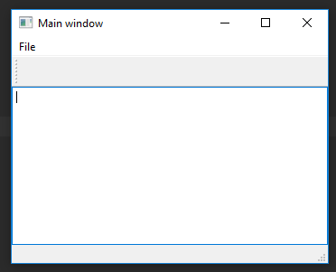

Menu va uning asboblar paneli ko‘rinishi.

**Nazorat savollari:**

1. Menuni hosil qilishi uchun qanday widgetdan foydalaniladi?
2. Statusbar widgeti nima vazifani bajaradi?
3. Menular panelini qaysi widgetdan foydalanib o‘rnatiladi?
4. QPixMap vidjetining imkoniyatlaridan qanday foydalaniladi?
5. QPixMap vidjetining qanday xususiyatlari mavjud?
6. QPixMap vidjeti yordamida rasm joylashtirish qanday amalga oshiriladi?